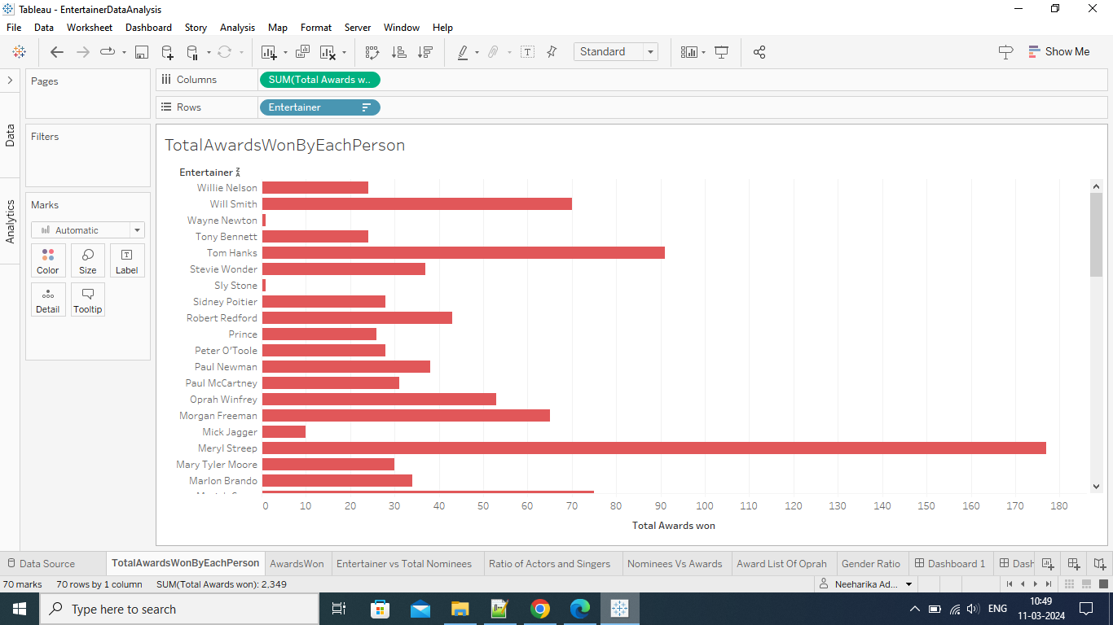

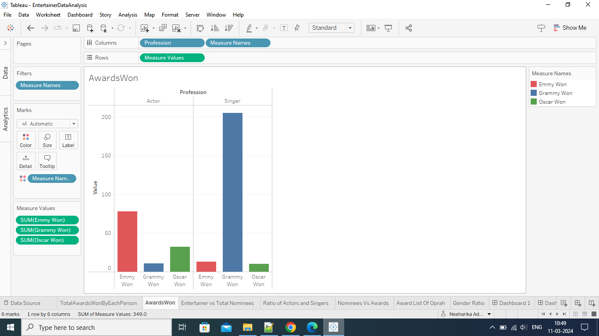

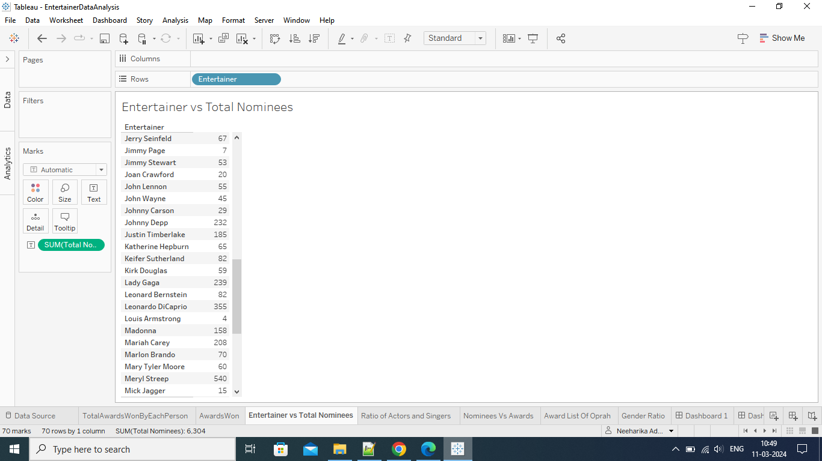

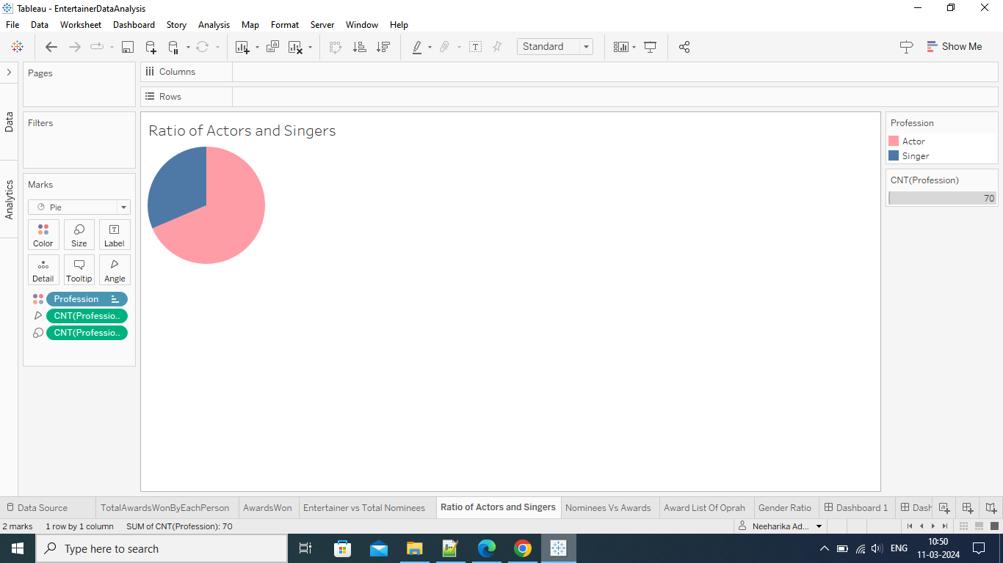

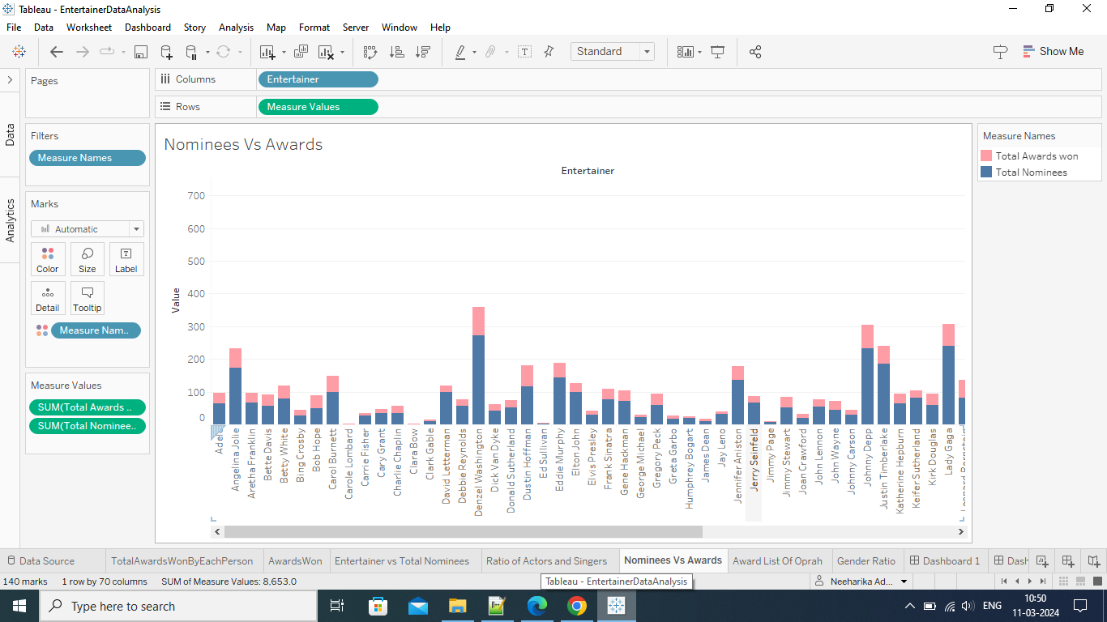

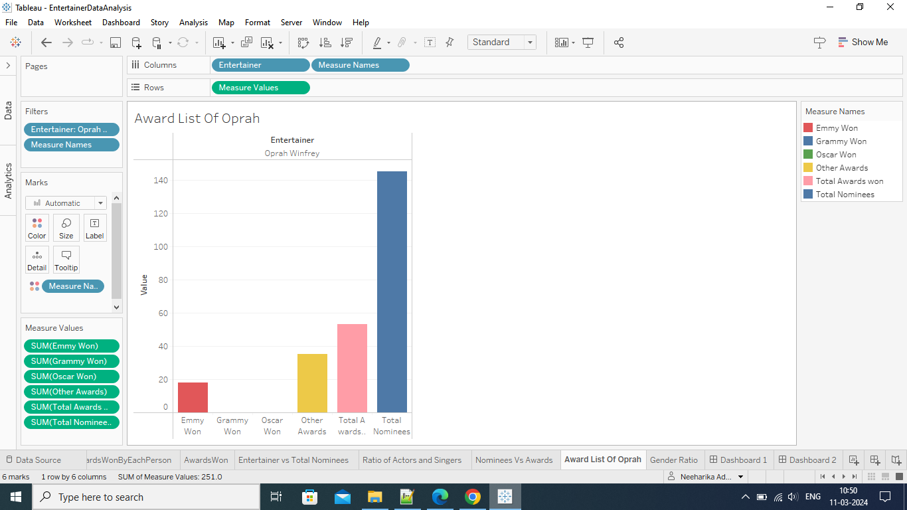

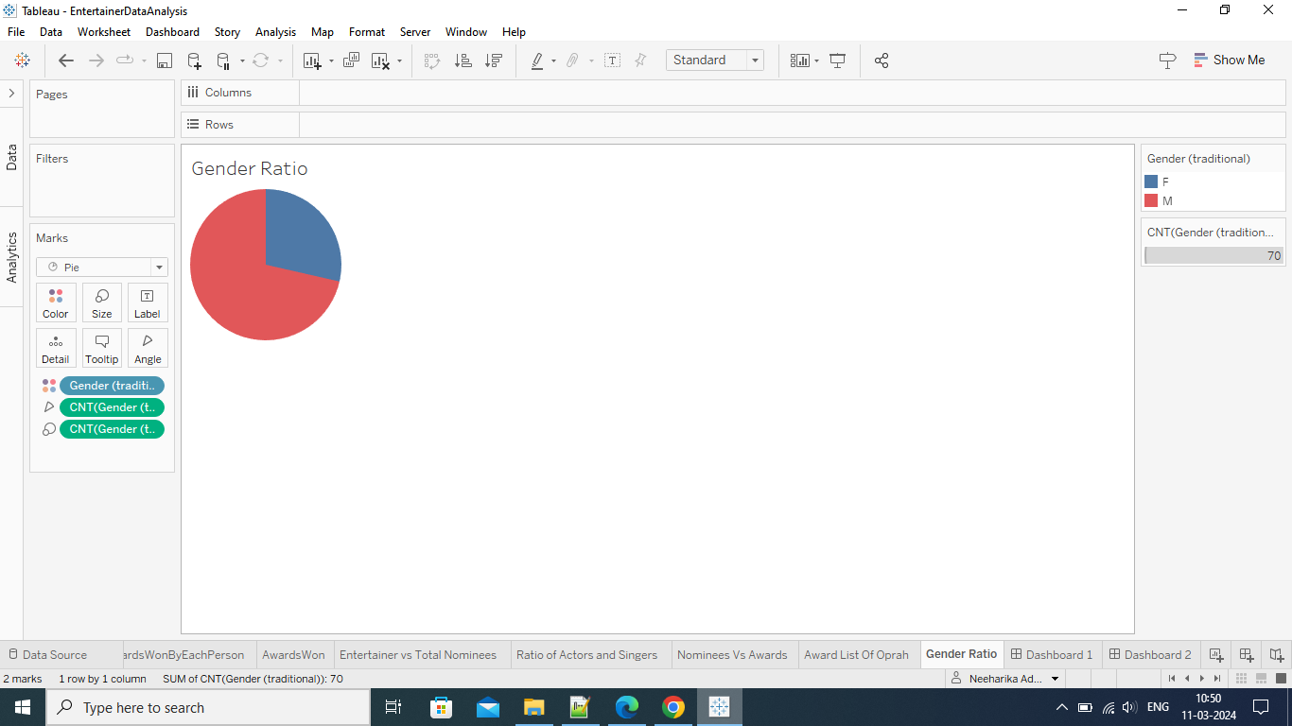

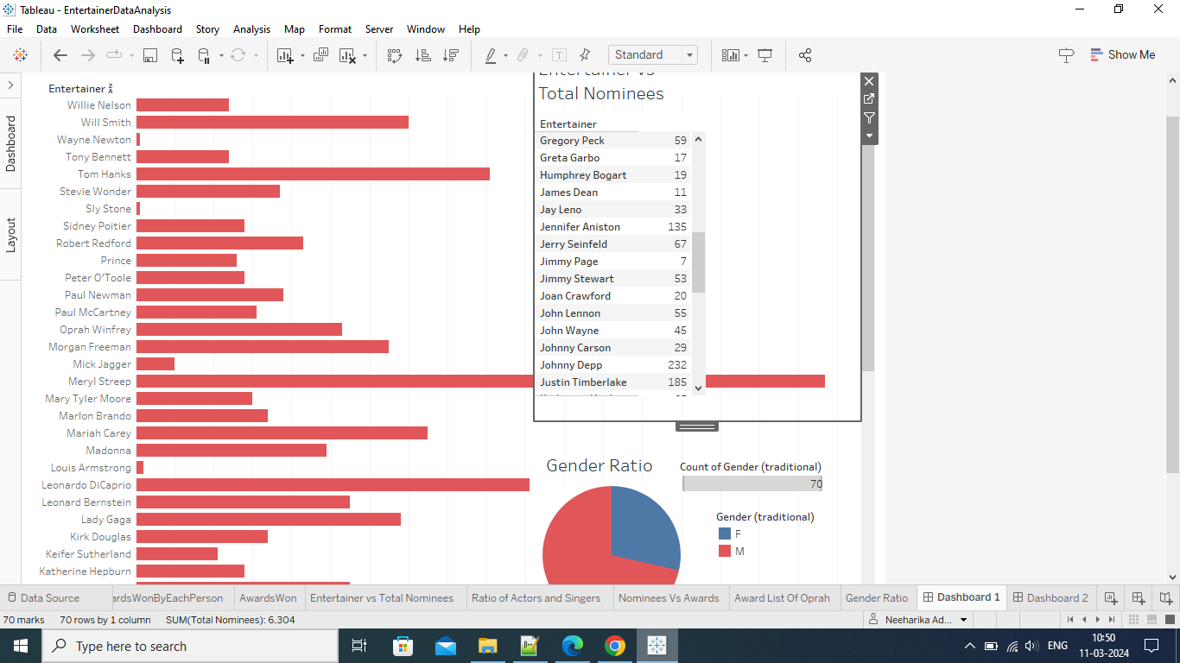

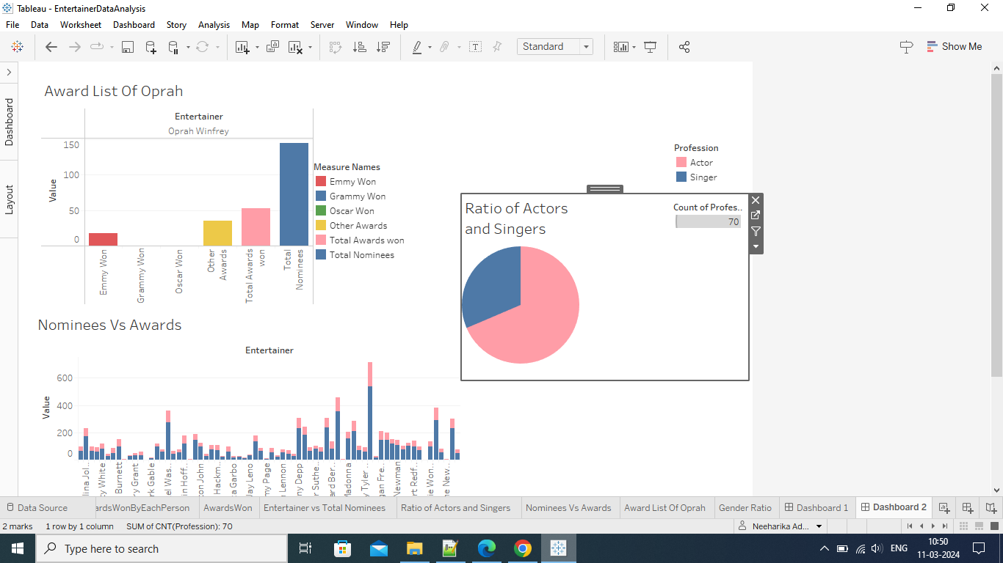

**Url for the dashboards**

[EntertainerDataAnalysis | Tableau Public](https://public.tableau.com/app/profile/neeharika.adella/viz/EntertainerDataAnalysis_17101683296330/Dashboard1?publish=yes)

[EntertainerDataAnalysis | Tableau Public](https://public.tableau.com/app/profile/neeharika.adella/viz/EntertainerDataAnalysis_17101683296330/Dashboard2?publish=yes)